**DSA-LAB ASSIGNMENT 1**

**(Name:Sneha Kondawar)**

**(Roll No:BT22CSE075)**

CODE:

#include <stdio.h>

#include <stdlib.h>

struct node {

    int coeff;

    int expo;

    struct node *next;

};

struct node *insert(struct node *head, int co, int ex) {

    struct node *temp;

    struct node * new = malloc(sizeof(struct node));

    new->coeff = co;

    new->expo = ex;

    new->next = NULL;

    if (head == NULL || ex > head->expo) {

        new->next = head;

        head = new;

    }

    else if(ex == head->expo){

        head->coeff +=co;

        free(new);

    }

    else {

        temp = head;

        while (temp->next != NULL && ex < temp->next->expo) {

            temp = temp->next;

        }

        if (temp->next != NULL && ex == temp->next->expo) {

            temp->next->coeff += co;

            free(new);

        }

        else{

        new->next = temp->next;

        temp->next = new;

    }

    }

    return head;

}

struct node *create(struct node *head, int n) {

    int coeff;

    int expo;

    for (int i = 0; i < n; i++) {

        printf("Enter the coefficient of term %d: ", i + 1);

        scanf("%d", &coeff);

        printf("Enter the exponent of term %d: ", i + 1);

        scanf("%d", &expo);

        head = insert(head, coeff, expo);

    }

    return head;

}

struct node *add_polynomial(struct node *head1,struct node *head2){

    struct node *HEAD= NULL;

    struct node* temp1=head1;

    struct node* temp2=head2;

    while(temp1 !=NULL && temp2 !=NULL){

        if(head1->expo>head2->expo){

            HEAD =insert(HEAD,temp1->coeff,temp1->expo);

            temp1=temp1->next;

        }

        else if(head1->expo<head2->expo){

            HEAD=insert(HEAD,temp2->coeff,temp2->expo);

            temp2=temp2->next;

        }

        else{

            int sum_coeff=temp1->coeff+temp2->coeff;

            if(sum_coeff !=0){

            HEAD=insert(HEAD,sum_coeff,temp1->expo);

            }

            temp2=temp2->next;

            temp1=temp1->next;

        }

        }

        while (temp1 != NULL) {

        HEAD = insert(HEAD, temp1->coeff, temp1->expo);

        temp1 = temp1->next;

    }

        while (temp2 != NULL) {

        HEAD = insert(HEAD, temp2->coeff, temp2->expo);

        temp2 = temp2->next;

    }

    return HEAD;

}

void print(struct node *head) {

    struct node *temp = head;

    if (head == NULL) {

        printf("No polynomial.");

        return;

    }

    while (temp != NULL) {

        printf("%dx^%d ", temp->coeff, temp->expo);

        if (temp->next != NULL) {

            printf(" + ");

        }

        temp = temp->next;

    }

}

int main() {

    struct node *head1 = NULL;

    struct node *head2 = NULL;

    struct node *head3 = NULL;

    int n, m;

    printf("Enter the number of terms in polynomial 1: ");

    scanf("%d", &n);

    head1 = create(head1, n);

    printf("Enter the number of terms in polynomial 2: ");

    scanf("%d", &m);

    head2 = create(head2, m);

    print(head1);

    printf(" \n");

    print(head2);

    head3=add_polynomial(head1,head2);

    printf(" \n");

    print(head3);

    return 0;

}

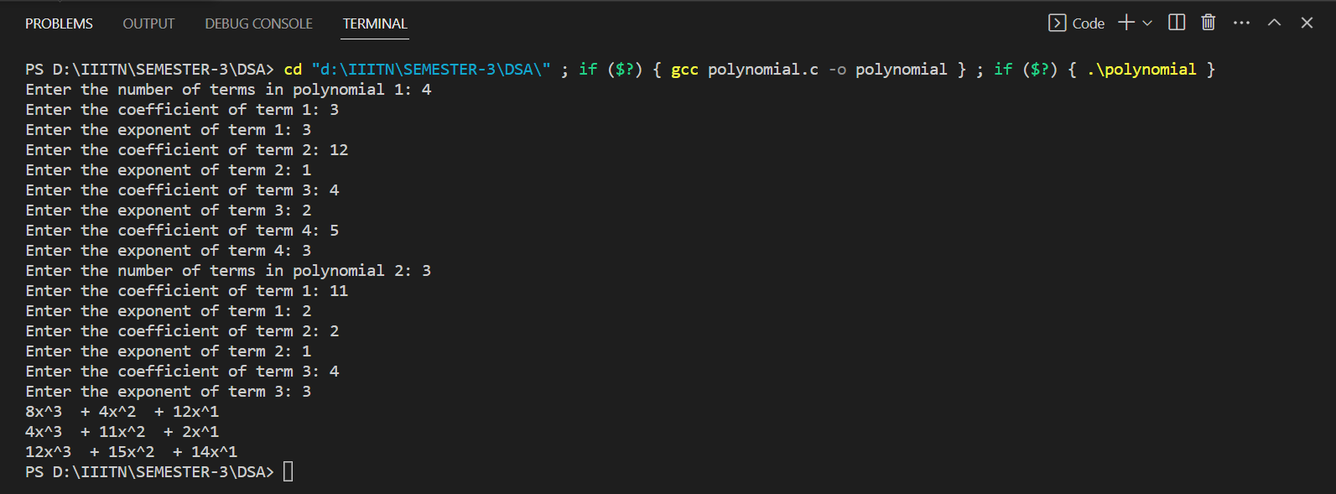OUTPUT: